Exp 5

Aim:
Experiment to implement any one of the classification algorithm(Decision tree and Naive Bayes) /Technique using python and user-defined functions.
1. Preprocess data. Split data into train and test set
2. Build a Classification model using the inbuilt library function on training data
3. Calculate metrics based on test data using an inbuilt function
4. Build a Classification model using a function defined by the student( model to be built using same training data).
5. Calculate metrics based on test data using an inbuilt function
Theory:

What is a Decision Tree?
A Decision Tree is a supervised machine learning algorithm used for classification and regression tasks. It is structured like a tree, where:
- Each internal node represents a decision based on an attribute.
- Each branch represents an outcome of the decision.
- Each leaf node represents a class label (final decision).
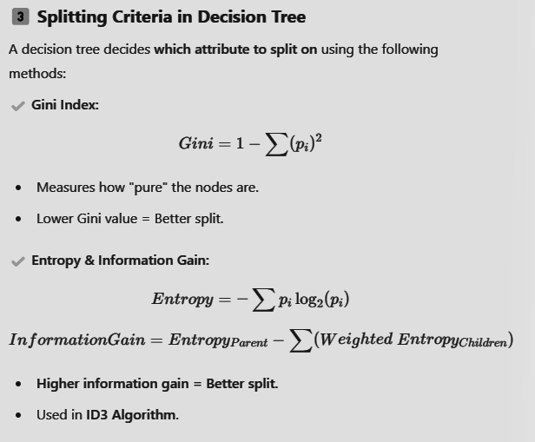

Naïve Bayes Classification Model

What is Naïve Bayes?
Naïve Bayes is a probabilistic classification algorithm based on Bayes' Theorem. It is called "Naïve" because it assumes that all features are independent, which is rarely true in real-world data.
Think of it as calculating the probability of a class given the features using conditional probability!
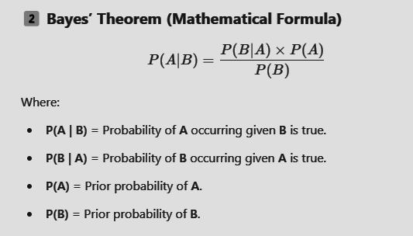

How Does Naïve Bayes Work?
- Calculate Prior Probabilities
  - Example: Probability of a player being Elite vs. Non-Elite.
- Calculate Likelihood (Feature Probabilities)
  - Example: Probability of Dribbling = 85 given the player is Elite.
- Apply Bayes’ Theorem
  - Compute the probability of the player being Elite based on all features.
- Classify Based on the Highest Probability
  - The class (Elite/Non-Elite) with the highest probability is chosen.

Dataset Overview:
- Title: FIFA 24 Player Stats Dataset
- Source: Kaggle
- Description: This dataset encompasses detailed statistics for players featured in FIFA 24, covering a wide array of attributes essential for in-depth analysis. It classifies if the player is elite or not.
- Link: Kaggle
Step wise Implementation
- Load the dataset and import required Libraries.
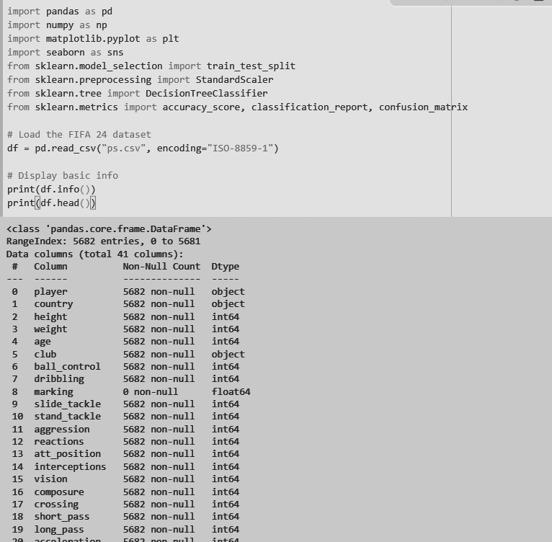

- Data preprocessing:
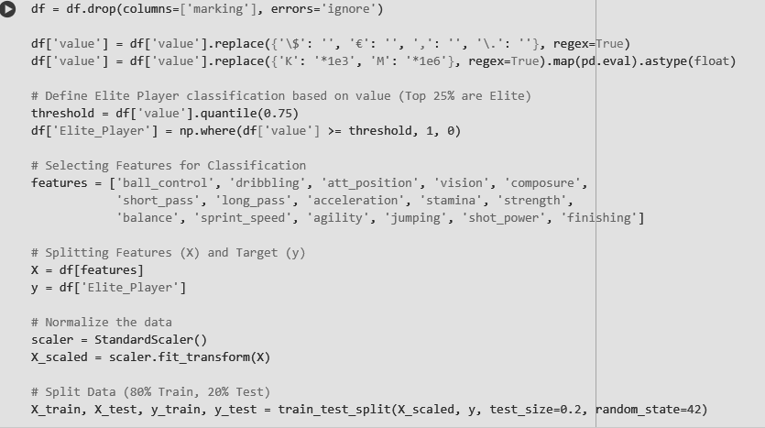

Convert "value" column to a numerical format
- In FIFA data, player values are written in formats like €1.5M, €750K, €500,000.
- We remove currency symbols (€, $) and convert K/M to actual numbers:
Define the Target Variable ("Elite Player")
- Elite players = Top 25% highest value players (Elite_Player = 1)
- Non-Elite players = Bottom 75% (Elite_Player = 0)
Select Features (X) and Target (y)
- We choose key football attributes like dribbling, ball control, sprint speed, finishing, etc.
- These are used to predict whether a player is Elite or Not.
Normalize Data Using StandardScaler()
- Since FIFA attributes have different ranges (e.g., Sprint Speed: 0-100, Strength: 0-100), we scale them:

- Train a Decision tree model
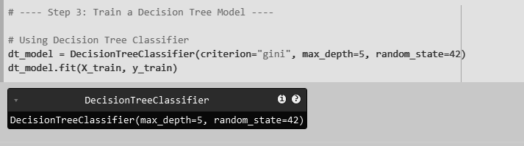

What We Do in This Step?
We use DecisionTreeClassifier() with:
- criterion="gini" → Measures how well the tree splits the data.
- max_depth=5 → Limits tree depth to prevent overfitting.
Train the model using clf.fit(X_train, y_train).

✔ Why Is This Step Important?
The model learns patterns from player attributes (X) and tries to classify them as Elite (1) or Non-Elite (0).
Limiting max_depth=5 prevents overfitting, where the tree memorizes the training data instead of generalizing.
- Evaluate model performance
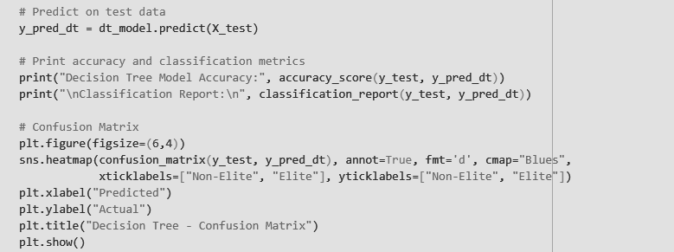

What We Do in This Step?
Predict player categories (Elite/Non-Elite) using clf.predict(X_test).
Calculate accuracy using accuracy_score(y_test, y_pred).
Print classification report to show Precision, Recall, and F1-Score.
Plot Confusion Matrix to visualize correct vs incorrect predictions.

✔ Why Is This Step Important?
Accuracy alone isn’t enough—we need Precision, Recall, and F1-score to understand model quality.
The Confusion Matrix shows where the model is making mistakes (e.g., misclassifying elite players).

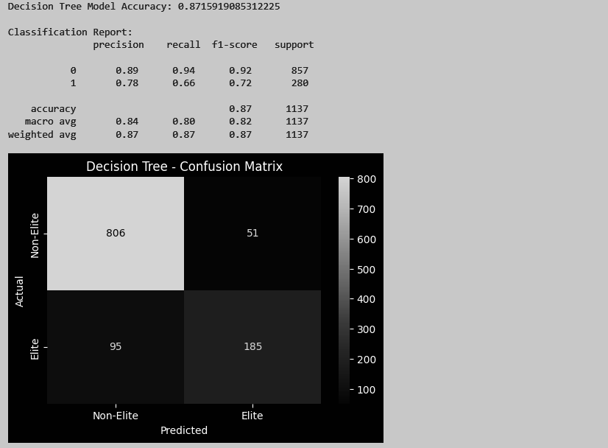

- Build a decision custom decision tree model:
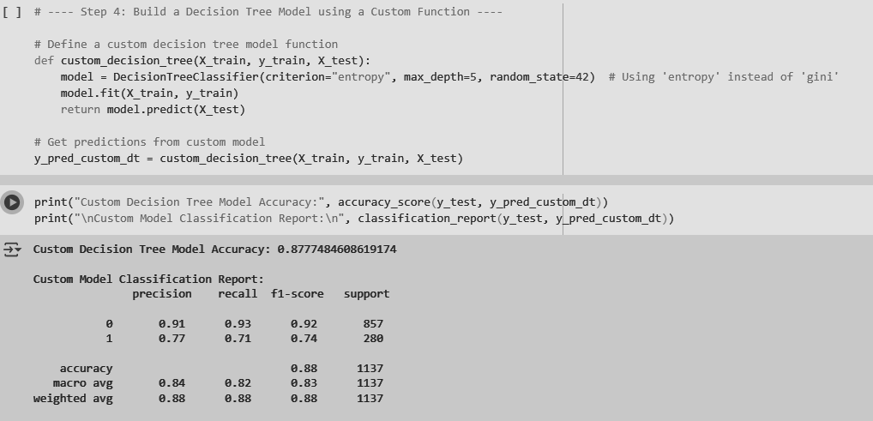

What We Do in This Step?
Define a function custom_decision_tree() that:
- Uses DecisionTreeClassifier() with criterion="entropy" instead of "gini".
- Trains the model using model.fit(X_train, y_train).
- Returns predictions using model.predict(X_test).

✔ Why Is This Step Important?
This step ensures we understand how a Decision Tree works by implementing it ourselves.
We compare "Gini" vs "Entropy" to check if different splitting criteria affect accuracy.

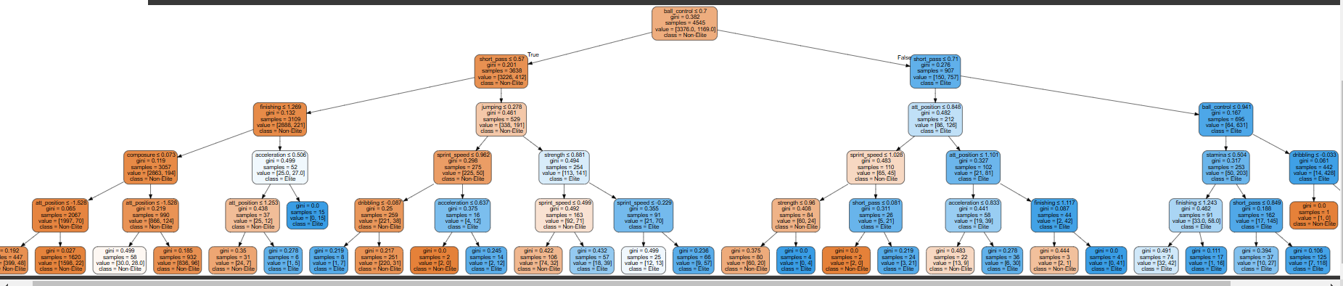
Text Based Decision tree
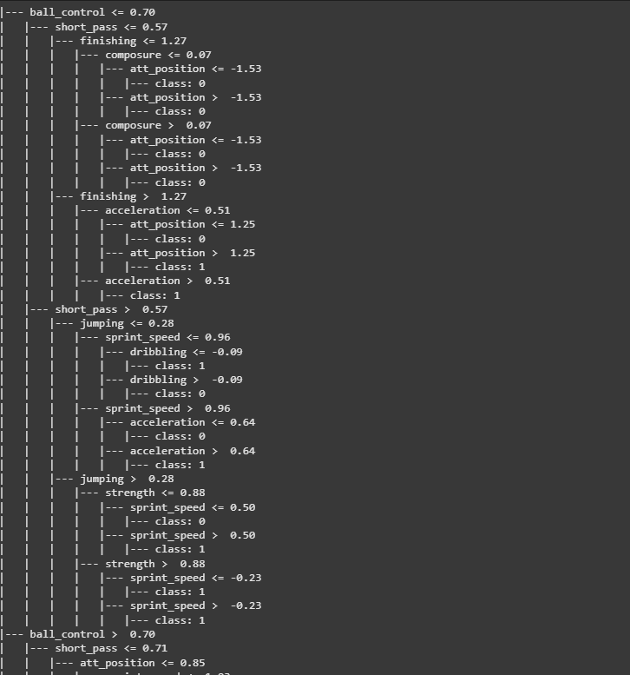
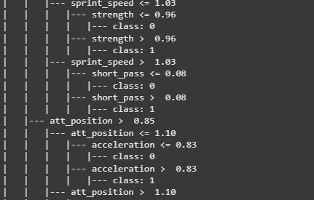
Method 2: Using Naive Bayes technique

- Import library and train naive bayes model
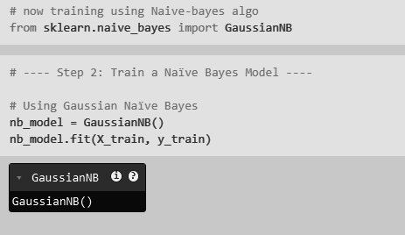
The model learns probabilities based on player attributes.
The Naïve Bayes formula assumes that all features are independent, which makes it fast but sometimes less accurate.

- Evaluate the Naive Bayes Model
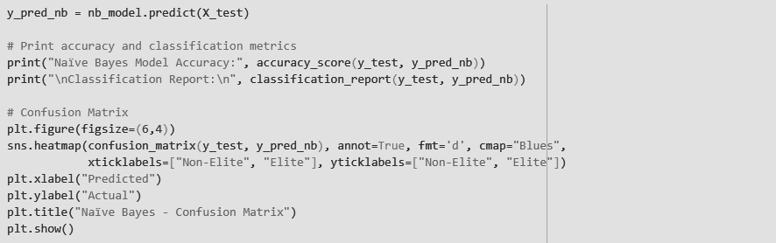

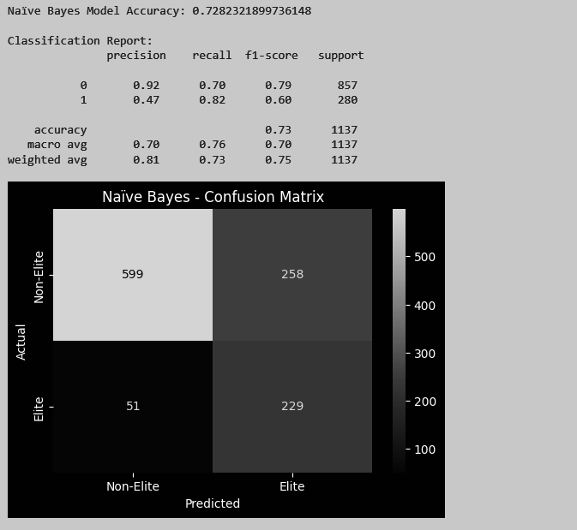
Check the model’s accuracy and analyze how well it classifies players.
Accuracy alone isn’t enough—we need Precision, Recall, and F1-score to see how many players are misclassified.
The Confusion Matrix shows false positives (wrongly classified Elite players) and false negatives (missed Elite players).

- Build a Naïve Bayes Model using a Custom Function
Instead of directly calling GaussianNB(), we wrap it in a function.
The function takes input data, trains the model, and returns predictions.

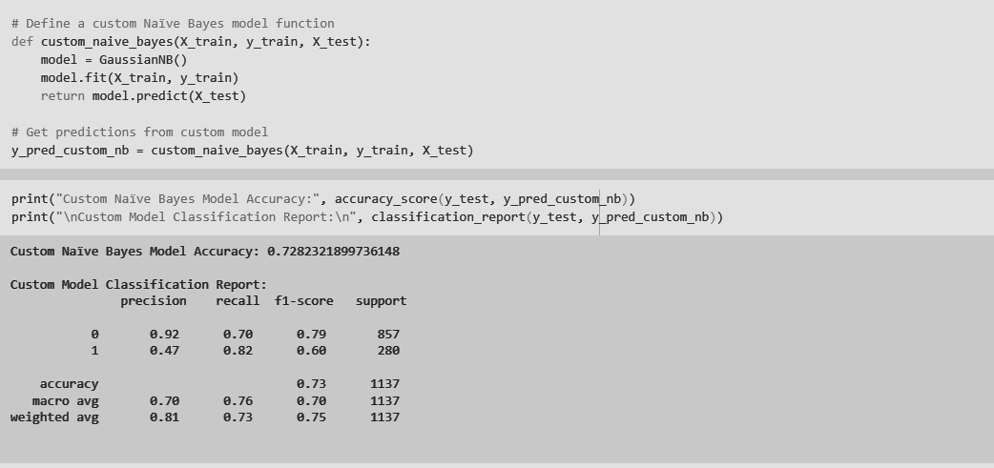

Conclusion:
Through this experiment, we implemented and compared Decision Tree Classification and Naïve Bayes Classification on the FIFA 24 dataset to predict whether a player is Elite (1) or Non-Elite (0) based on key performance attributes.
- Decision Tree performed better for structured, feature-rich data like FIFA player stats, as it considers feature interactions.
- Naïve Bayes was faster but less accurate due to its assumption that features are independent, which is not entirely true for FIFA player attributes.
- Custom models provide more flexibility for tuning and reusability.
- Choosing the right classification algorithm depends on the dataset and problem requirements—for structured numeric data, Decision Trees perform better, while for text-based classification, Naïve Bayes is more efficient.

